Environment Policy

Our Vision
Our vision as a company is to demonstrate value to our customers and society, and our commitment to protecting and enhancing the environment. We take our environmental stewardship role seriously and have a dedicated Water Strategy and Environment Team, whose purpose is to manage water and protect the environment for a sustainable future.
All employees should see protection of the environment as an essential part of their job, reporting and responding to environmental incidents when they arise. We also expect colleagues to know where to find more information about environmental issues or contact the environment team if they are unsure.
Managers and leaders should ensure implementation and monitoring of compliance with legal and regulatory responsibilities and our environmental policy. Within their teams they are expected to always promote environmental best practice, integrating environmental protection into work planning, and identifying opportunities to improve environmental performance.
Company executives are responsible for overseeing the effective delivery of our environmental policy and ensuring all business is conducted in line with the policy.
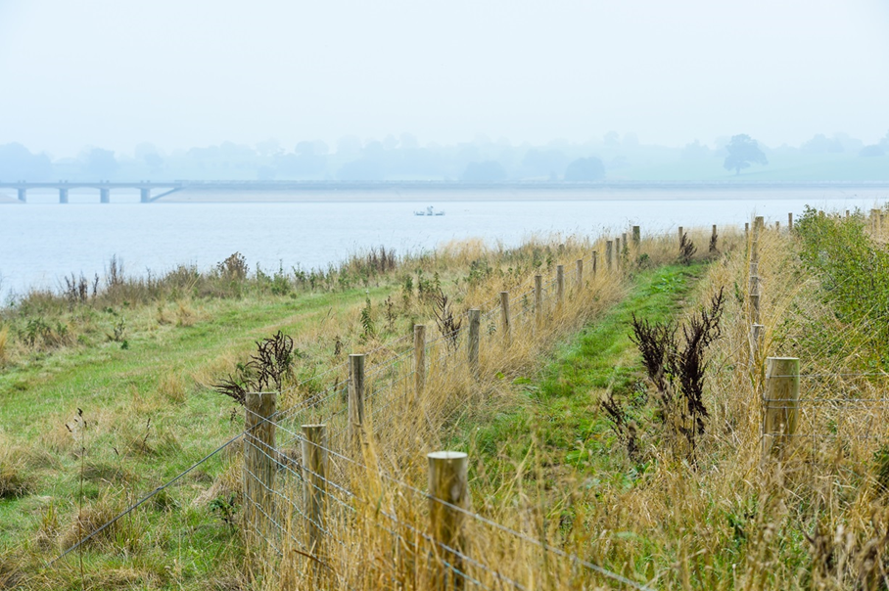

Policy Commitments
Carbon Emission Reduction
- We will reduce our carbon emissions from our operations into the atmosphere, where possible switching to renewable energy sources and implementing efficiency schemes, by 2050. This includes both our own operational emissions and the embedded carbon associated with our supply chain.
Water Resource Management
- As detailed in our Water Resources Management Plan, we are committed to securing water for the future, ensuring our abstractions are environmentally sustainable, reducing leakage and promoting water efficiency through targeted initiatives such as universal metering.
- We will use an adaptive planning approach to ensure long term supply resilience in the face of climate change and population growth, working to improve our understanding of these risks to our operations.
Compliance and pollution prevention
- We will meet all our legal and regulatory environmental requirements. Prevent and mitigate the impacts of pollution, use resources sustainably, reduce waste where possible and follow best practice.
- We will incorporate environmental considerations into all our business decisions.
- We will deliver our Water Industry National Environment Program (WINEP) obligations in each regulatory period.
- We will assess our supply chain partners for their environmental performance, ensuring they have the appropriate environmental credentials and meet the necessary legal and regulatory requirements.
- We will monitor and evaluate our environmental performance, striving for improvement, whilst maintaining transparency by reporting progress to stakeholders internally and externally.
Biodiversity
- We will continue to deliver sustainable nature-based solutions and environmental benefits across our regions. We will continue to make grants available to local communities and organisations through our successful PEBBLE biodiversity improvement fund, and to farmers and landowners through our SPRING catchment management scheme.
- We will support biodiversity on our landholdings by enhancing biodiversity at sites identified as ecologically important, preventing the spread of invasive non-native species, and ensuring no biodiversity loss through our operations.
Training and Engagement
- We will promote wider awareness and understanding of environmental issues among our customers and our people, providing training where appropriate, to ensure our employees are technically competent in their roles.
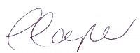
Caroline Cooper
Strategy and Regulation Director
31 March 2024

